

**Gulf Aluminium Rolling Mill B.S.C. (c)**

**ICT Department**

**Contractor Management System**

*Software Requirement Specifications*

Document Revision History:

|  |  |  |  |
| --- | --- | --- | --- |
| **Version** | **Date** | **Remarks** | **Author** |
| 1.0 | 15 Aug 2021 | Draft created | Ervin Brosas |
| 1.1 | 05 Sep 2021 | Added new fields in the Contractor Registration form which include the following:   * Supervisor In-charge * Blood Type | Ervin Brosas |
|  |  |  |  |
|  |  |  |  |

Document Approval (Sign-off):

|  |  |  |  |
| --- | --- | --- | --- |
| **Approver Name** | **Position** | **Signature** | **Date** |
| Hasan AlAradi | Health Safety & Env. Manager |  |  |
| Ahmed Ebrahim | Acting Head of Procurement |  |  |
| Fahad Albasam | Executive Manager - Administration |  |  |
|  |  |  |  |

Table of Contents

INTRODUCTION 4

Purpose 4

Audience 4

OVERALL DESCRIPTION 4

Project Perspective 4

System Interface 4

User Interface 4

Software Interface 5

SPECIFICATIONS 5

Functional Requirements 5

Project Scope 5

Web Forms 5

DEVELOPMENT PHASES 10

CHANGE MANAGEMENT PROCESS 10

# INTRODUCTION

## Purpose

This document delineates the overall description, functional requirements, and scope in developing the Contractor Data Management System which will be integrated as a new module in the Time and Attendance System (TAS).

## Audience

This document is intended for Safety & Security, Purchasing, and HR Department Stakeholders for their perusal on various functionalities which will be implemented in the Project, as well as to identify any additional requirements that will better enhance the system. This is also intended for Software Engineers to provide guidelines in designing the technical specifications of the Project in accordance to the user’s requirements.

# OVERALL DESCRIPTION

## Project Perspective

The current Access System which is used to manage the contractor’s information as well as printing the ID card has many limitations that include the following:

* No validation during data entry which results to duplicate records for the same contractor.
* No search functionality to check whether a contractor already exist in the database.
* No integration with other systems such as JDE, GAP, and TAS, hence, the cost center and contractor’s company name need to be entered manually which leads to spelling mistakes.
* No option to delete the contractor record especially if the information entered is wrong.
* Difficult to manage and customize the system because it is procured from a 3rd party supplier which we do not have maintenance support.

With the above-listed deficiencies in the current system, the need to develop a new one to replace it is critical to resolve and eliminate data integrity issues. The Project aims to design a new data management system which will be integrated as a new module in TAS, wherein the contractor’s information will be entered and at the same time, will allow printing of the ID card which will contain both the contractor’s basic information and all valid licenses.

### System Interface

The Project will be integrated with other existing systems such as, JDE Enterprise One, GAP, and TAS. Related data across the systems will be synchronized in real time to maintain data integrity and reliability.

### User Interface

Users will interact with the system through a Graphical User Interface (GUI) forms that will be accessible using an internet browser such as, Internet Explorer (IE) or Edge. The system will be hosted in IIS Web Server, hence, there is no need to deploy it physically into the user’s machine.

### Software Interface

The Project will be developed using the following web development technologies: ASP.Net, .NET Framework 4.7, Entity Framework 6, HTML5, CSS, JavaScript, jQuery, AJAX, JSON, Bootstrap, ADO.NET, LINQ, and Telerik Reporting.

# SPECIFICATIONS

## Functional Requirements

This Project ensures all users with the following functionalities:

* No duplicate record would exist in the database because data validation will be enforced during Contractor registration.
* A search functionality will be provided to allow users to search for Contractor records based on predefined filter criteria.
* An option to delete invalid records will be provided to Admin Users only in order to maintain reliable data.
* Security in the system will be strictly enforced and only authorized users would be able to access the available forms and reports.
* All reports can be exported to other file formats such as, Excel, PDF, and CSV files.
* The ID card that will be generated from the system will contain the Contractor’s basic information in the front page and the list of all eligible licenses at the back page.

## Project Scope

The system will be used to manage the Contractor’s information only. It will not cater the employee and visitor’s information because there are already existing systems that handle and manage such data which include, JDE and Visitor Pass module (part of TAS). The configuration of the data to be embedded into the ID card as well as setting up the access to turnstile and barrier reader devices will be done through the UNIS system, which is outside the scope of the Project.

## Web Forms

The following user-interface forms will be provided to end-users for managing the contractor information:

1. **Contractor Registration Form** – This form will be used to register a new contractor into the system. Data validation will be enforced to ensure reliable data and to prevent duplicate entries. A sample layout of the form is shown in the screenshot below, as well as the description of each available fields.

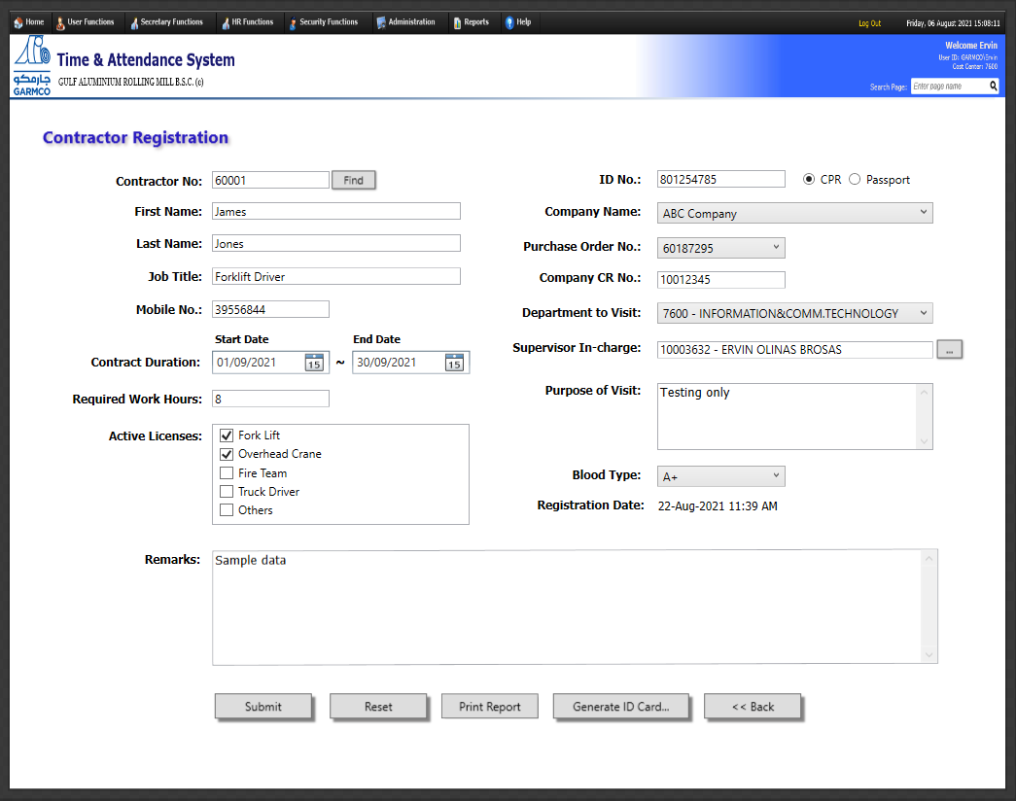

**Data Entry Fields:**

|  |  |
| --- | --- |
| Field Name | Description |
| *Contractor No.* | Refers to the unique reference number that will be used to identify the Contractor in the system. This number will be generated automatically by the system based on the maximum identity seed value from the database table plus 1. It consists of 5 digits starting with the number 6 and uses the following sequence pattern: 6xxxx. |
| *ID No. (CPR / Passport)* | Refers to the identity card number (either CPR or passport number) which the Contractor needs to provide to the Security Personnel in order to be registered in the system. *(Note: This is a required field which cannot be left blank.)* |
| *First Name* | This is a self-explanatory field which refers to the first name of the Contractor. *(Note: This is a required field which cannot be left blank.)* |
| *Last Name* | This is a self-explanatory field which refers to the last name of the Contractor. *(Note: This is a required field which cannot be left blank.)* |
| *Company Name* | Refers to the name of the company where the Contractor works. This field will be shown as a drop-down list box which will allow the user to select the company from the list of registered contractors in JDE. *(Note: This is a required field which cannot be left blank. If the contractor company is not in the list, users can type manually the company name.)* |
| *Purchase Order No.* | The list of all POs will be populated in this drop-down list field upon selecting the company name from the list of registered contractors shown in the “Company Name” field. Take note that a contractor company can have multiple purchase order requests in the system, and the user should select the correct PO to map the contractor request against the payment. This field is optional and can be left unspecified. |
| *Company CR No.* | This is an optional field which refers to the CR number of the company where the Contractor works. |
| *Job Title* | Refers to the occupation of the Contractor. *(Note: This is a required field which cannot be left blank.)* |
| *Mobile No.* | Contact number of the Contractor |
| *Department to Visit* | Refers to the cost center where the Contractor will be visiting or working at. *(Note: This is a required field which cannot be left blank.)* |
| *Supervisor In-charge* | Refers to the GARMCO employee who is the reporting supervisor of the contractor. *(Note: This is a required field which cannot be left blank.)* |
| *Purpose of Visit* | Optional field which refers to the reason why the Contractor needs to work with the designated department. |
| *Contract Duration* | Need to provide the start and end date of the Contractor’s work duration. *(Note: This is a required field which cannot be left blank. Also, when the end date has passed, the Contractor’s ID card can no longer be used to swipe at the barrier or turnstile.)* |
| *Blood Type* | This is a drop-down list wherein the user can select the blood type of the contractor. The available options are the following: A-, A+, B-, B+, O-, O+, AB-, AB+. This field is optional and can be left unspecified. |
| *Registration Date* | The date generated by the system when the Contractor’s registration information has been submitted. |
| *Active Licenses* | Refers to the list of all valid licenses that the Contractors possess. *(Note: This is a required field which cannot be left blank.)* |
| *Remarks* | Any additional information that the Security Personnel may provide which is relevant to the Contractor’s visit to the company. |

1. **Contractor Inquiry Form** – This form will be used to search for contractor records that exist in the database based on certain filter criteria provided in the form to fine tune the query results. Data will be displayed on the grid in a tabular format, and the link to view the attendance records for each contractor will be provided. 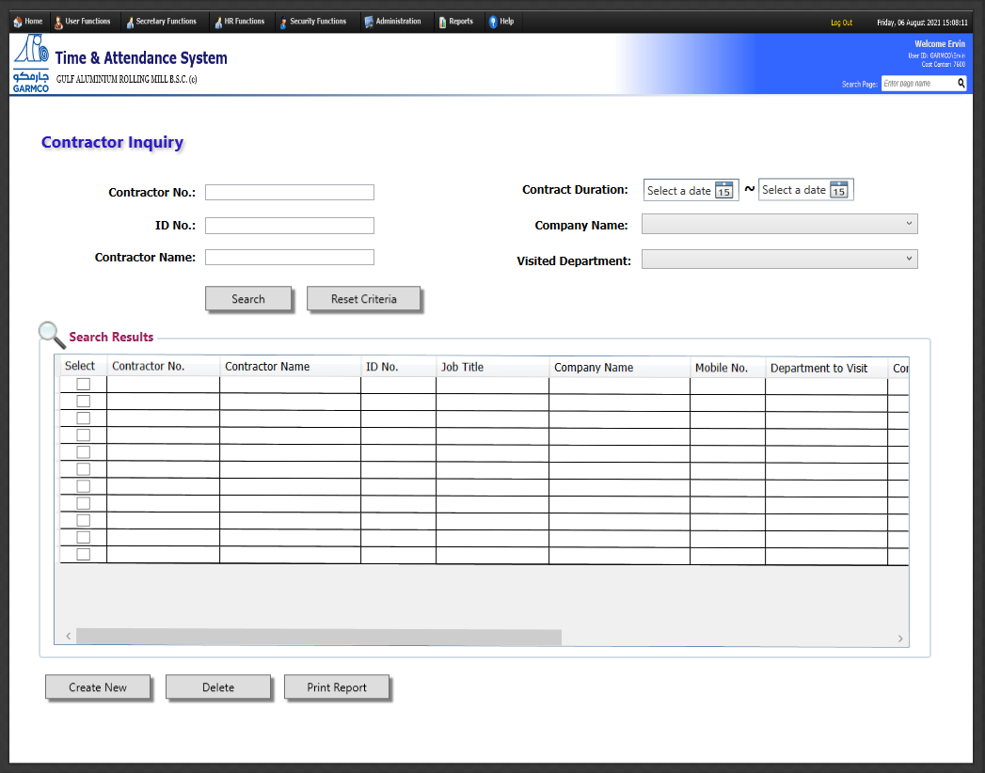

**Search Criteria Fields:**

|  |  |
| --- | --- |
| Field Name | Description |
| *Contractor No.* | This field allows to search for specific record based on the Contractor’s unique reference number. |
| *ID No.* | Allows searching for Contractor’s record based on CPR or passport number. |
| *Contractor Name* | Find matching records based on a search string that matches or exists in the Contractor’s first name and last name. |
| *Contract Duration* | Search records based on specific period |
| *Company Name* | Find matching records based on a search string that matches or exists in the Contractor’s company name. |
| *Visited Department* | Find matching Contractor records based on the selected department. |

1. **Contractor ID Card Generator** – This form will be used to generate the Contractor’s ID card which will be used to swipe at the turnstile or barrier reader devices.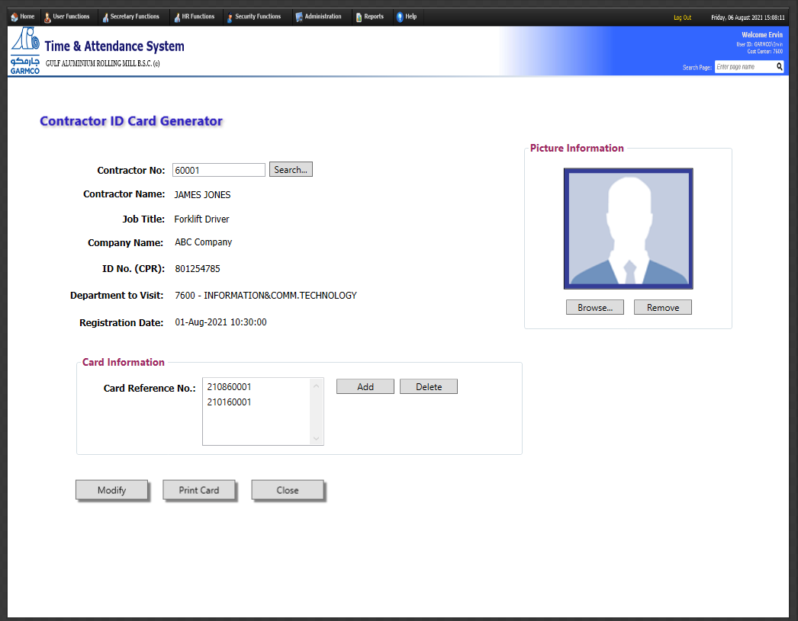

**Data Entry Fields:**

|  |  |
| --- | --- |
| Field Name | Description |
| *Contractor No.* | This is a mandatory field which needs to be specified in order to load the Contractor’s information for ID card printing. |
| *Card Reference No.* | This is the card number that will be linked to the UNIS system for configuring the access to the reader devices. |
| *Contractor Photo* | Refers to the scanned photo of the Contractor which can be fetched from the file system. Valid image file formats include the following: PNG, BMP, and JPG. *(Note: This is a required field which cannot be left blank.)* |

# DEVELOPMENT PHASES

The Project is estimated to be completed in 32 man-days. The development process is summarized in the project plan screenshot shown below. 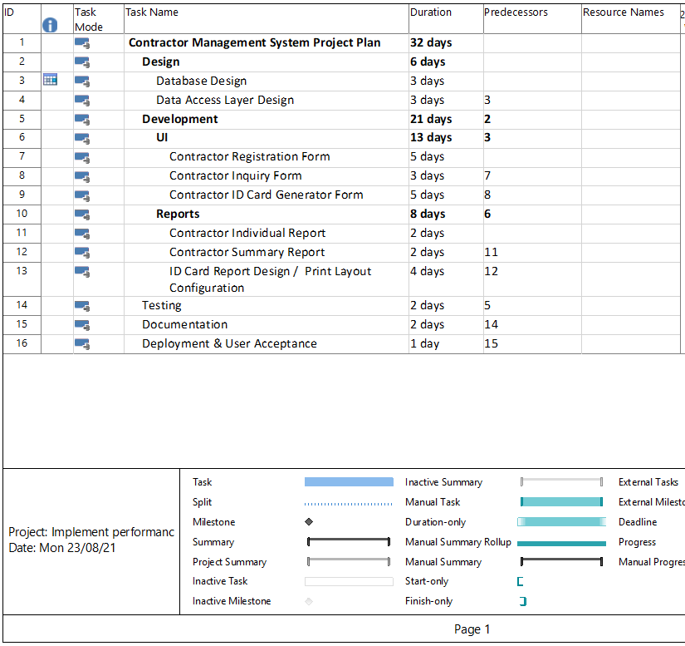

# CHANGE MANAGEMENT PROCESS

Significant changes to the software requirements document shall be only be made when it is the consensus of the group that they are necessary and feasible. Any other changes after the approval of this document will not be entertained, but rather will be implemented by sending a Helpdesk System Enhancement Request. This is to make sure that development process will not be interrupted, and the targeted project deadline will be met.